**Deploy Image to Container Registry**

Note: this example is continue of last demo “Create & Deploy Docker Image”

Azure Container Registry allows you to build, store, and manage images for all types of container deployments.

Step 1: Open Microsoft Azure Portal

**+ Create a resource -> Containers -> Container Registry**

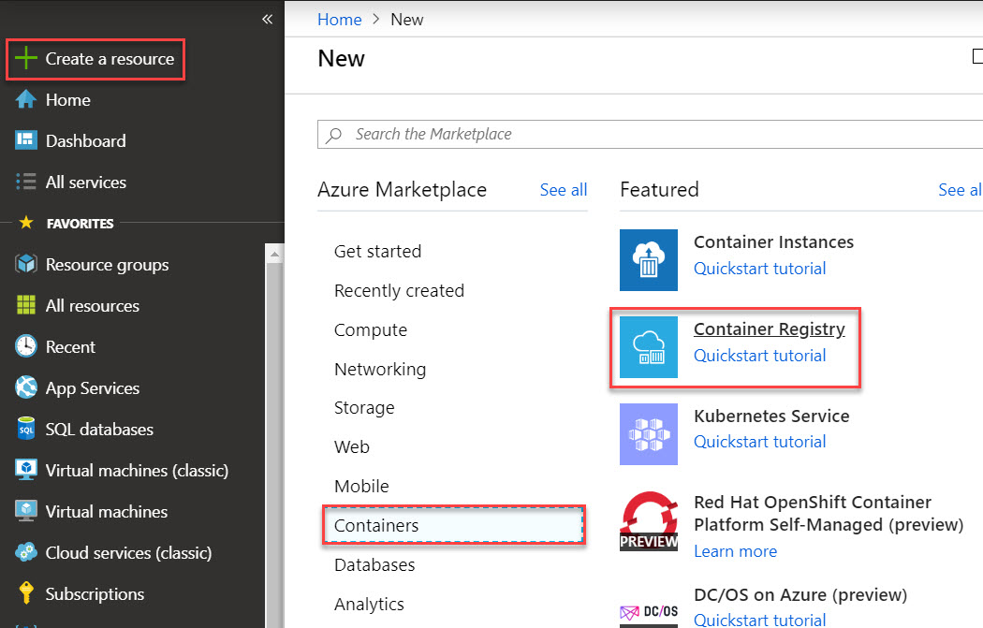

Step 2: Create Container registry

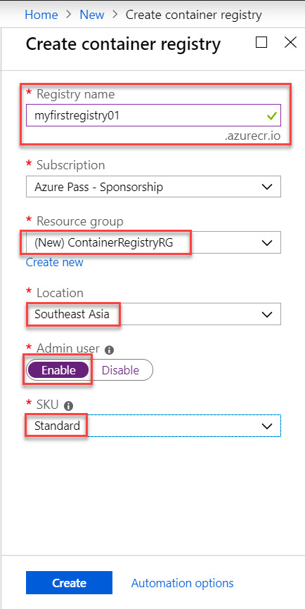

Step 3: Select Access Keys and check Registry Name, Login Server, Username & Password. Later on will use this credentials

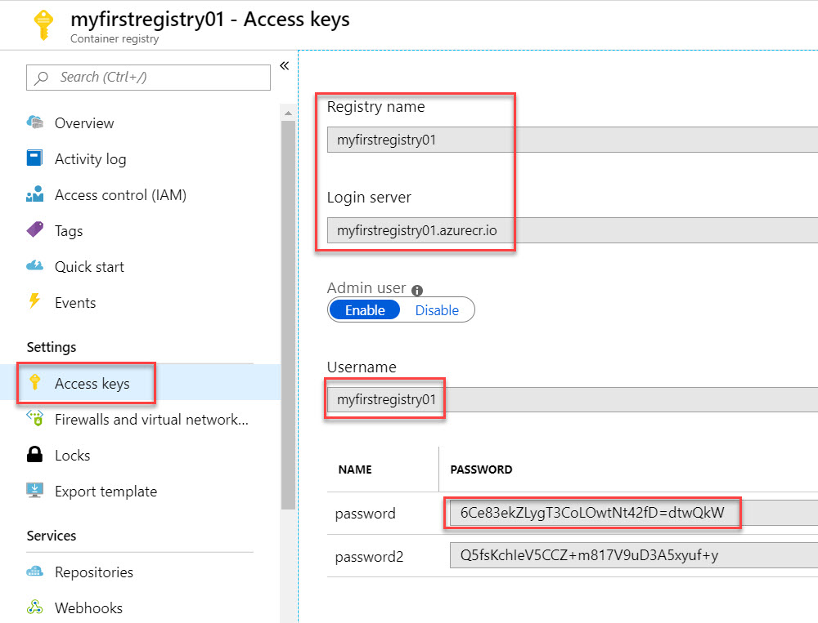

Step 4: type

cd..

cd site

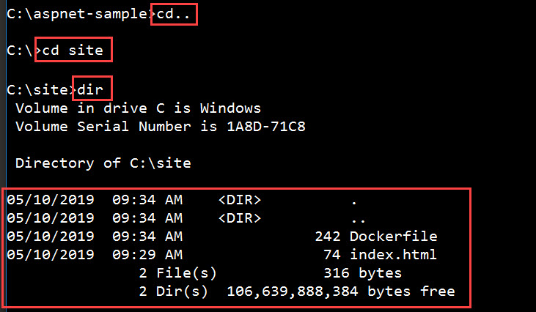

Step 5: Login to Docker Registry

*docker login --username <user-name> --password <password> <login-server>*

Ex.

docker login –u myfirstregistry01 -p 6Ce83ekZLygT3CoLOwtNt42fD=dtwQkW myfirstregistry01.azurecr.io

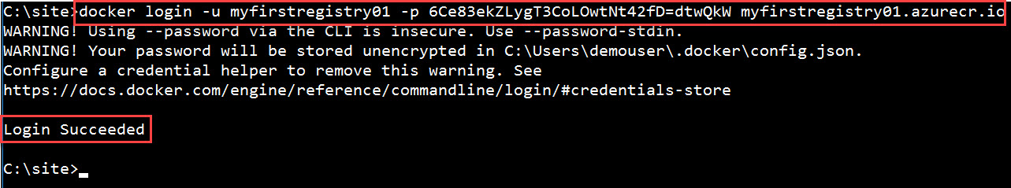

Step 6: tag the image with container registry name

*docker tag myfirstsite <registryname>.azurecr.io/myfirstsite*



Step 7: Type

docker images

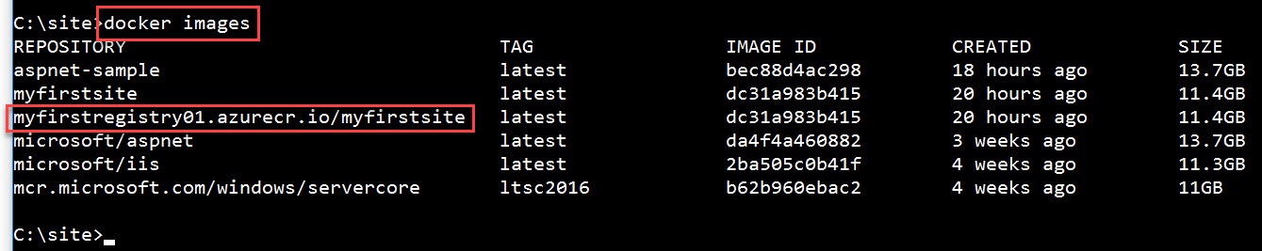

Step 8: Now push tagged image to Azure Container Registry

*docker push <login-server>/myfirstsite*

Ex.

docker push myfirstregistry01.azurecr.io/myfirstsite

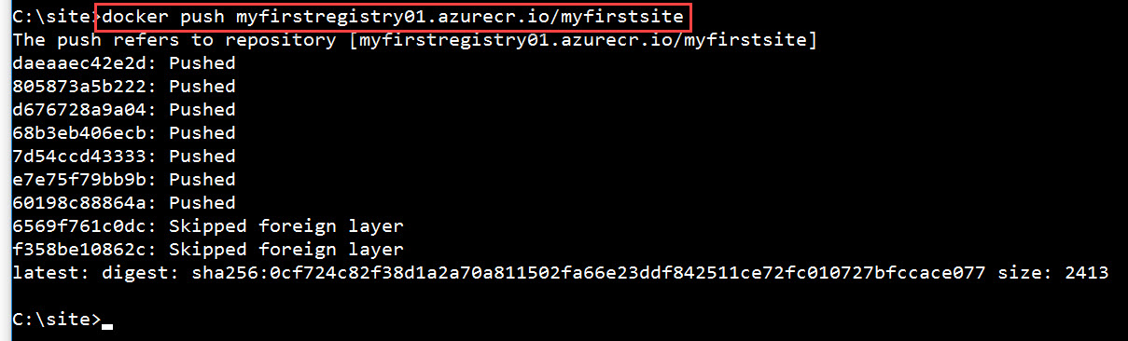

Step 9: Navigate to Azure Portal & Check Azure Container Registry

